Students Web Application

1. Purpose of this document
2. General Functioning
3. Rational Schema Diagram
4. Notes

## 

## Purpose of Documentation

* The purpose of this document is to give technical information about database design and project implementation and functionality .

## General functioning

* Register /Login users /
* Show, Create, Edit and Delete Classes for Students.
* Show, Create, Edit and Delete Students.
* Store Classes, Students that entered by users.

## 3 Rational Schema Diagram

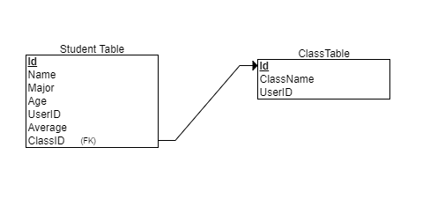

I saved id of current user in every record get created by the user

* I’m not sure it's the correct way to do this so please check it out

*you will find the code inside student and Stdclasses controller

ApplicationDbContext context = new ApplicationDbContext();

var UserManager = new UserManager<ApplicationUser>(newUserStore<ApplicationUser>(context));

ApplicationUser currentUser = UserManager.FindById(User.Identity.GetUserId());

## 4 Notes

* There is a custom Style sheet inside content folder
* I used bootstrap theme, individual user accounts authentication, entity framework code first
* If there is something missing or wrong please let me know.

## 